hw1 fetch feed
Pipe Web Address: http://pipes.yahoo.com/pipes/pipe.info?_id=JAmIPDTh3RGBK7pB1L3fcQ
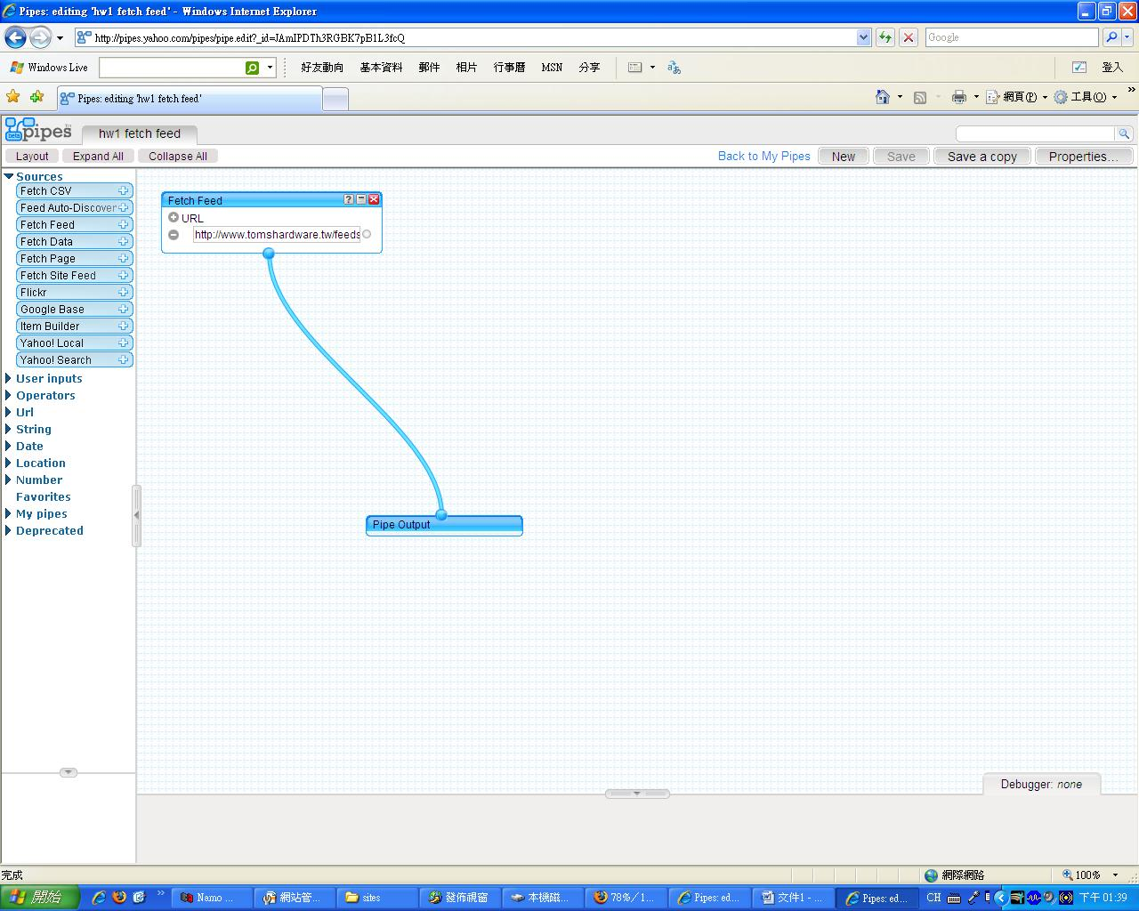

hw2 filter

Pipe Web Address: http://pipes.yahoo.com/pipes/pipe.info?_id=QBFvyTfh3RGERU_bbLsjiw

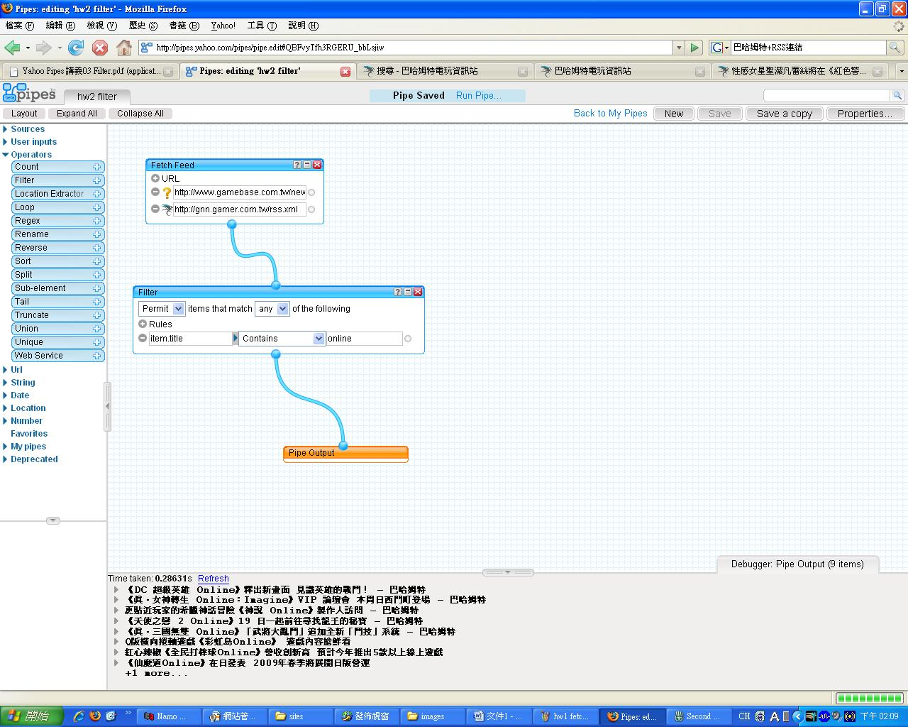

hw3 fetch site feed

Pipe Web Address: http://pipes.yahoo.com/pipes/pipe.info?_id=kFWPFzrh3RGz4sZP1L3fcQ

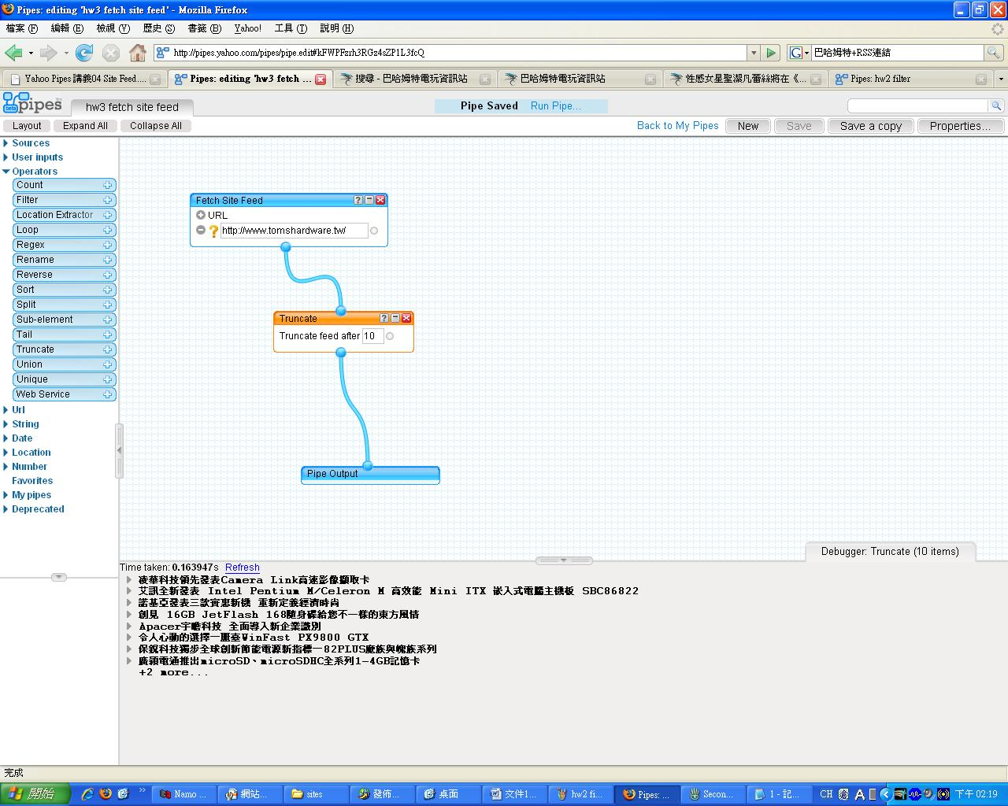

hw4 flickr

Pipe Web Address: http://pipes.yahoo.com/pipes/pipe.info?_id=oodIyTrh3RG1HtJABRNMsA

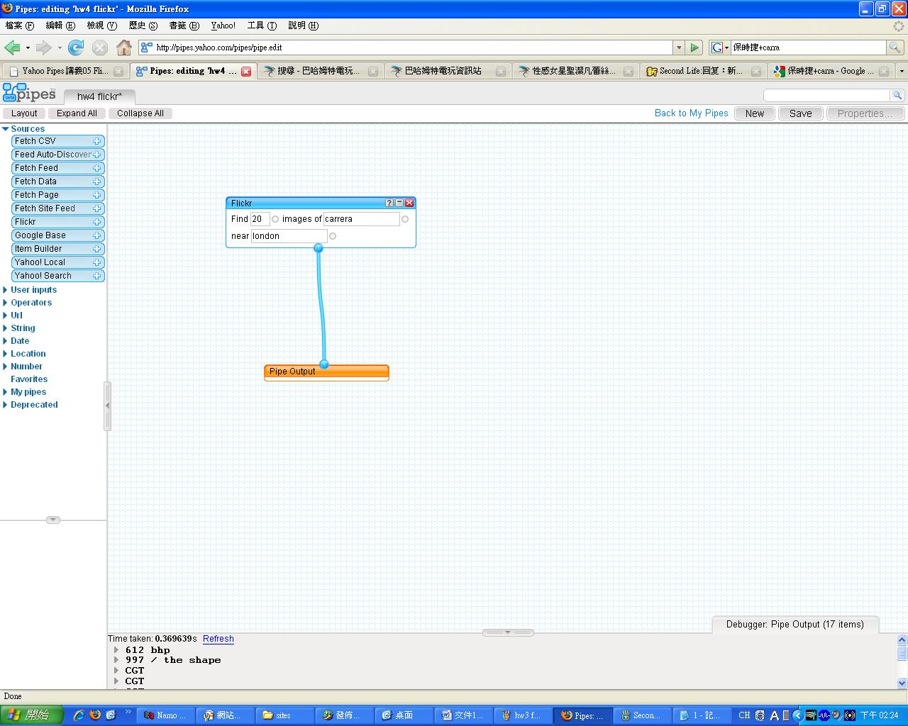

hw5 google base

Pipe Web Address: http://pipes.yahoo.com/pipes/pipe.info?_id=kNE2pjzh3RGhFUBd1L3fcQ

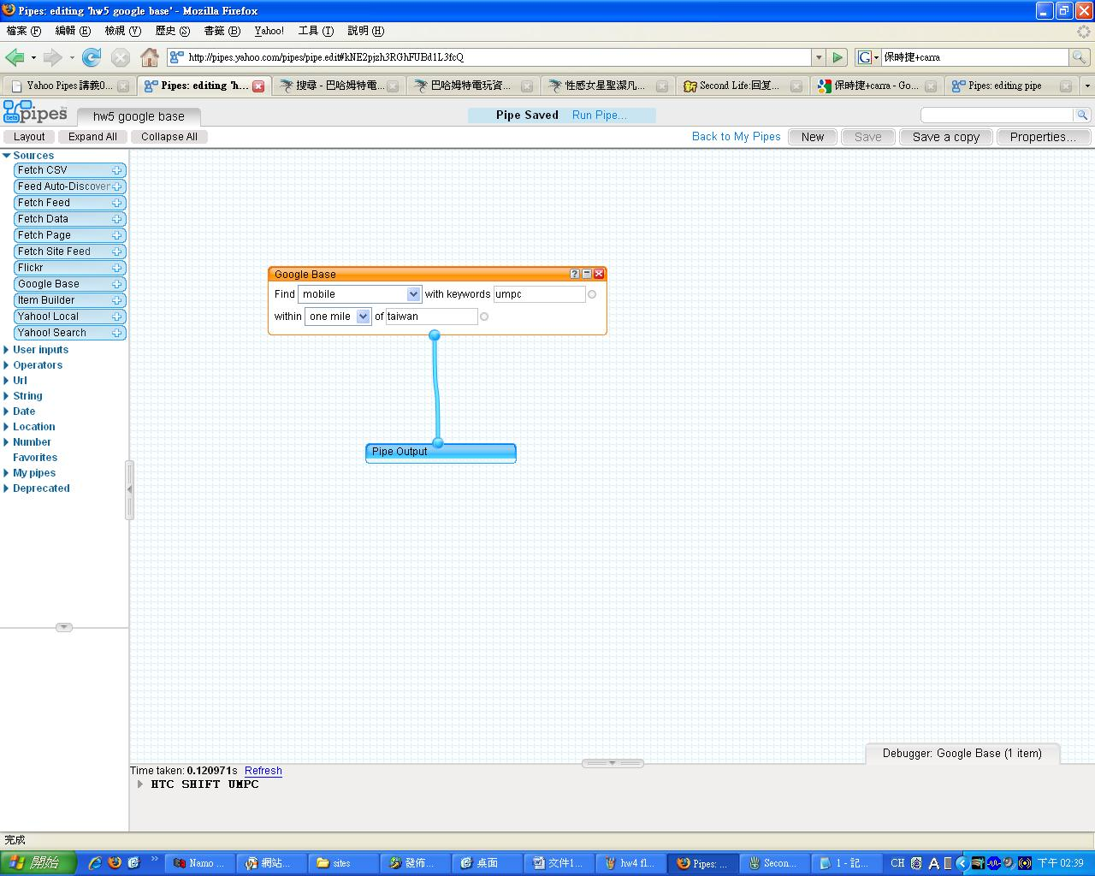

hw6 yahoo search

Pipe Web Address: http://pipes.yahoo.com/pipes/pipe.info?_id=KrPxeD3h3RG_vSwqBRNMsA

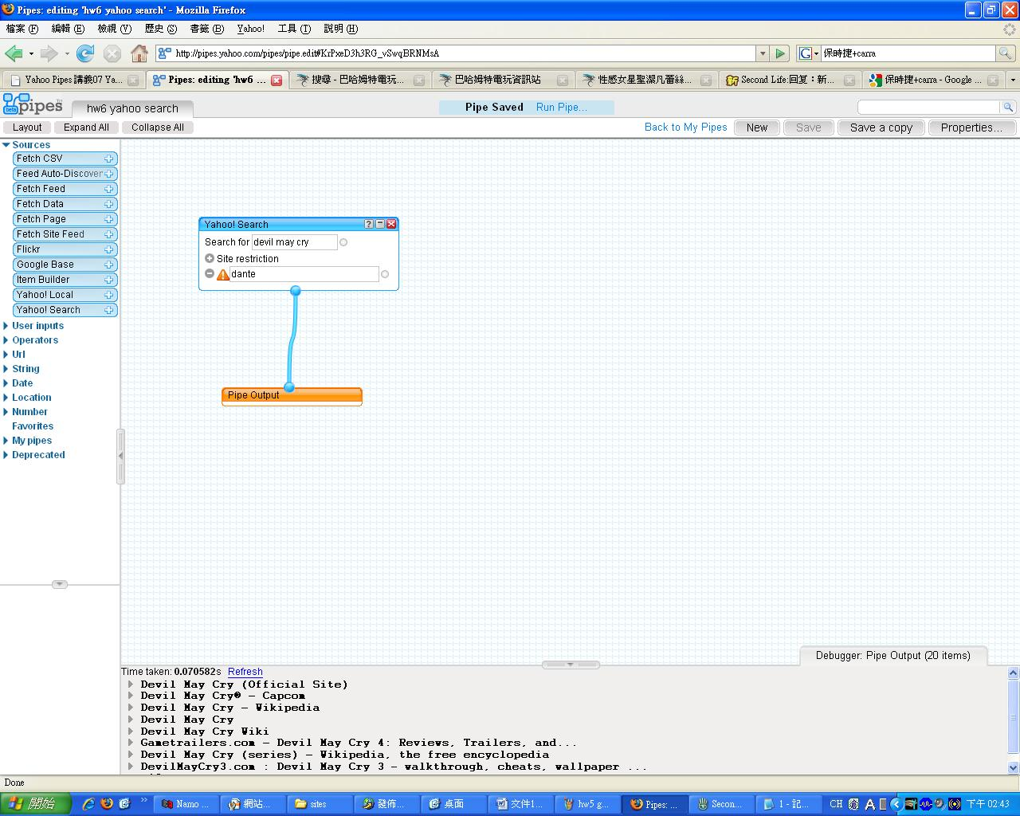

hw7 text input

Pipe Web Address: http://pipes.yahoo.com/pipes/pipe.info?_id=DN20ij7h3RG13IVi1L3fcQ

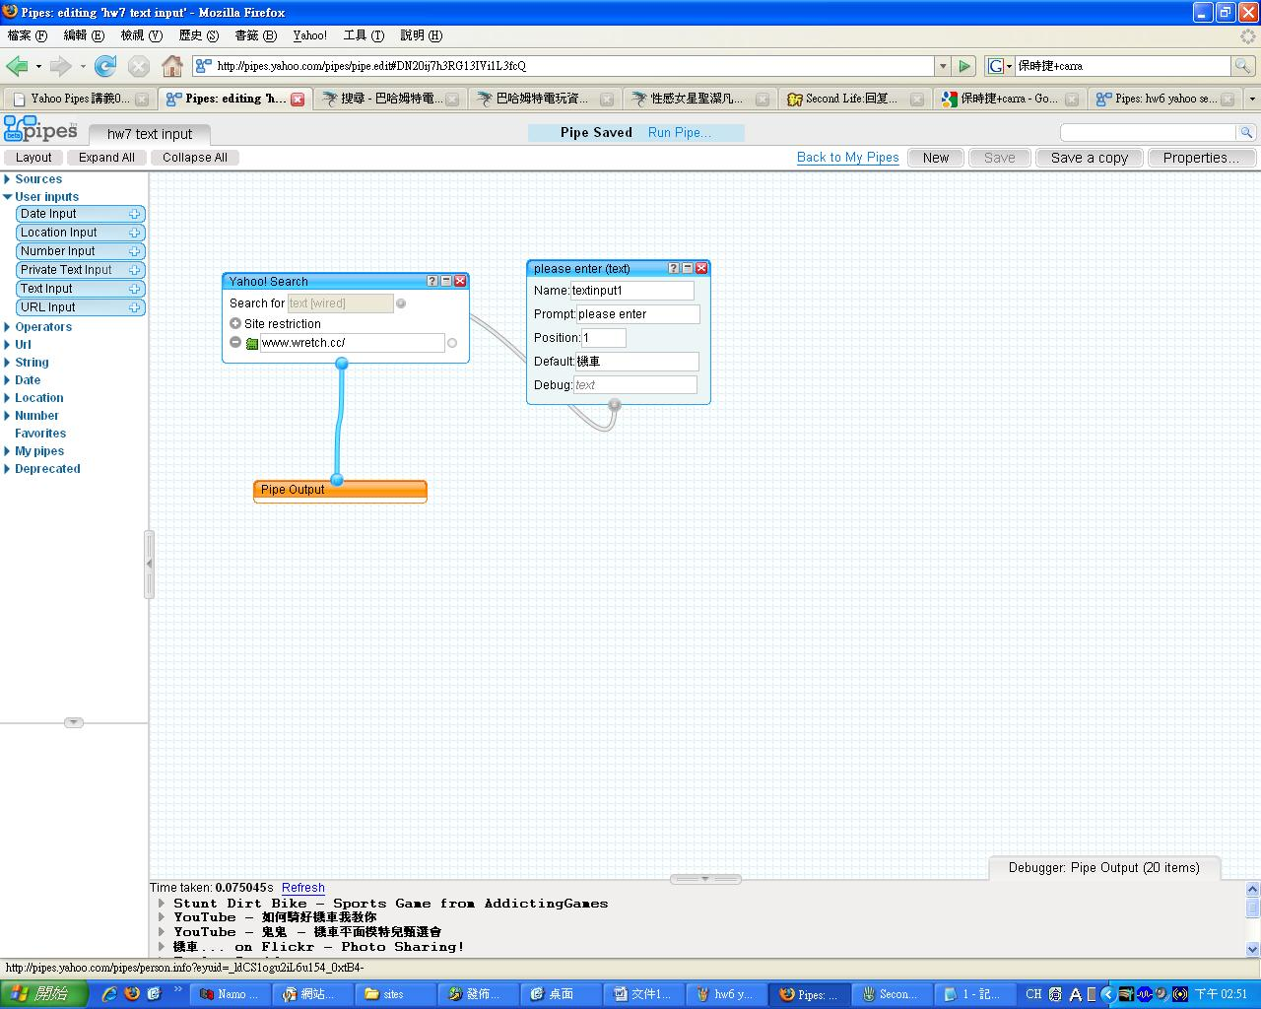

hw8 url input

Pipe Web Address: http://pipes.yahoo.com/pipes/pipe.info?_id=RObCEj_h3RGLZmzcbLsjiw

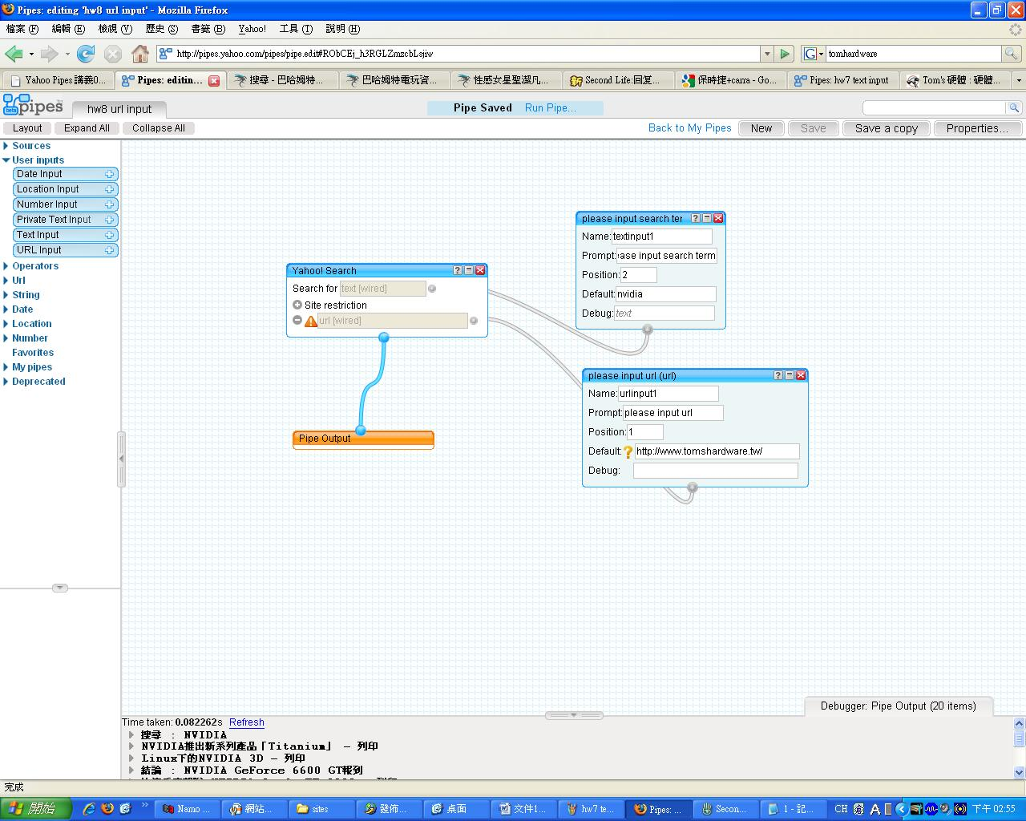

hw9 number input

Pipe Web Address: http://pipes.yahoo.com/pipes/pipe.info?_id=zqesNkDh3RGstpdFBRNMsA

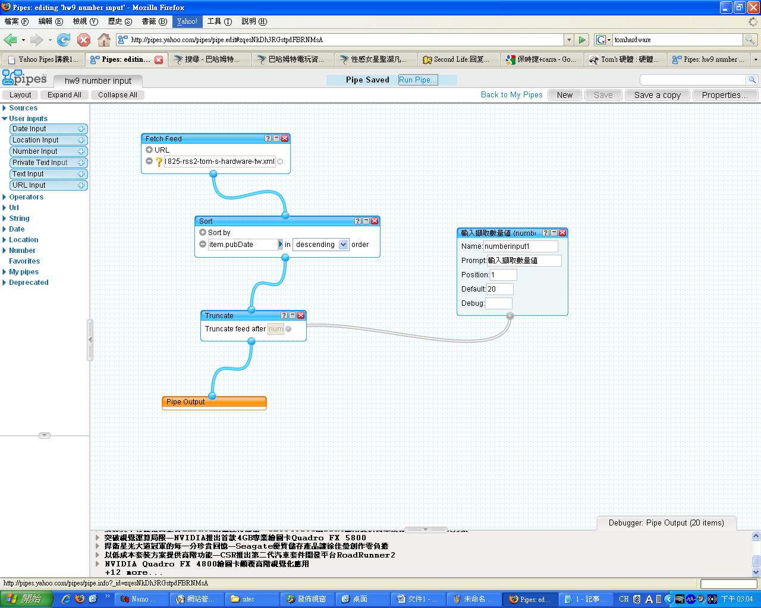

hw10 yahoo local

Pipe Web Address: http://pipes.yahoo.com/pipes/pipe.info?_id=brTPb0Hh3RGJqhbWbLsjiw

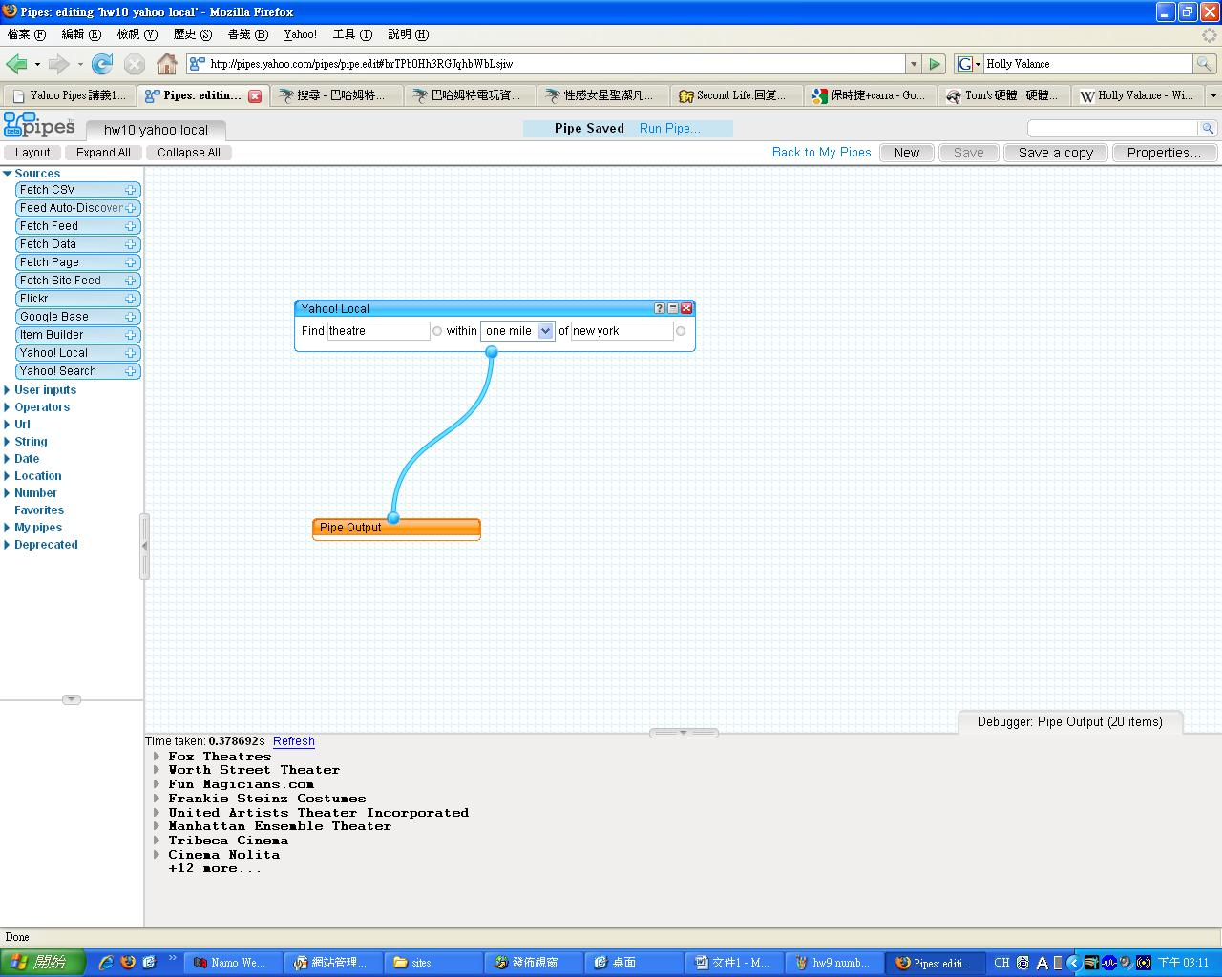

hw11 yahoo local & input

Pipe Web Address: http://pipes.yahoo.com/pipes/pipe.info?_id=RsEhPULh3RG2ocZd1L3fcQ

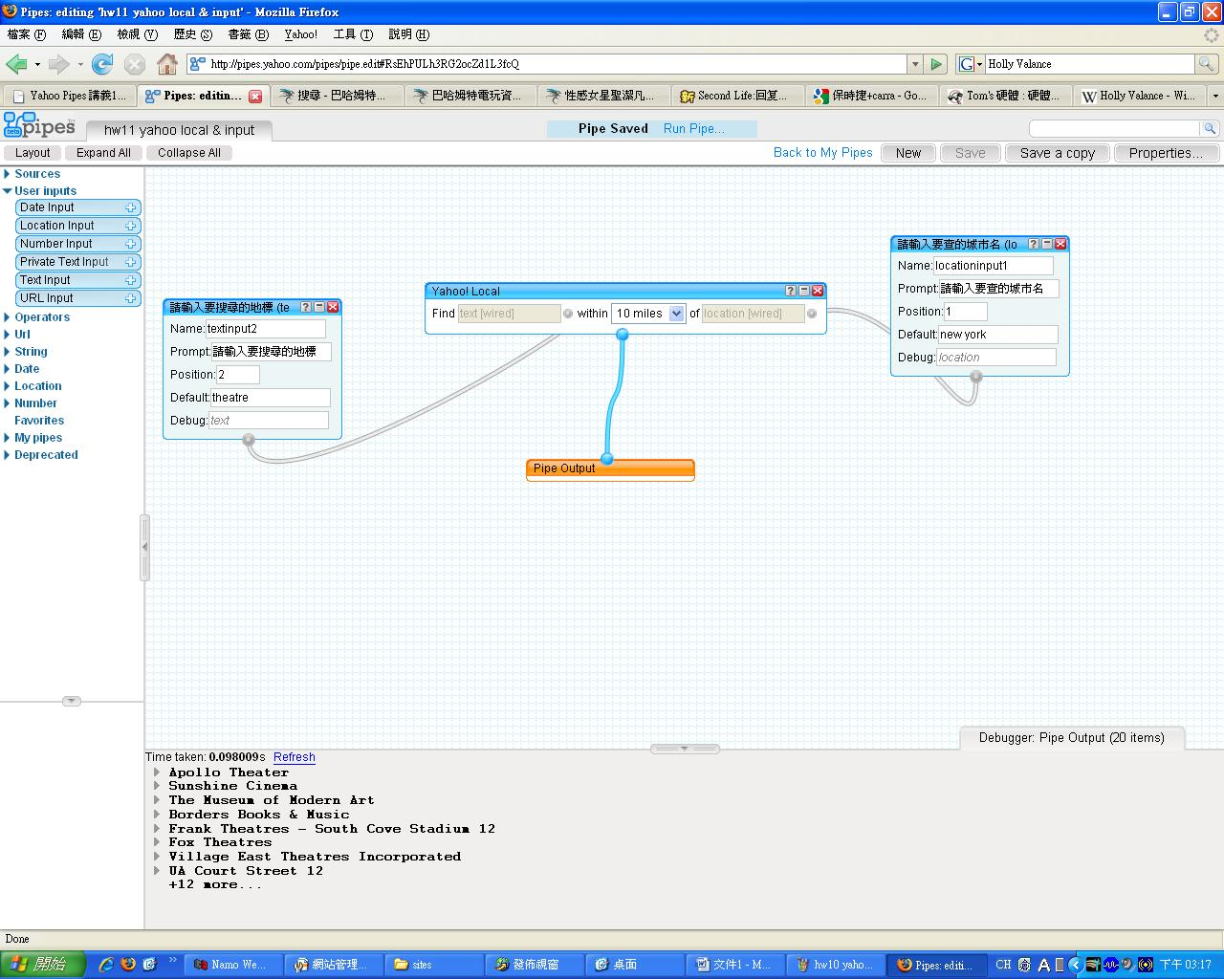

hw12 date input

Pipe Web Address: http://pipes.yahoo.com/pipes/pipe.info?_id=HmXpR0Th3RGVRkhYBRNMsA

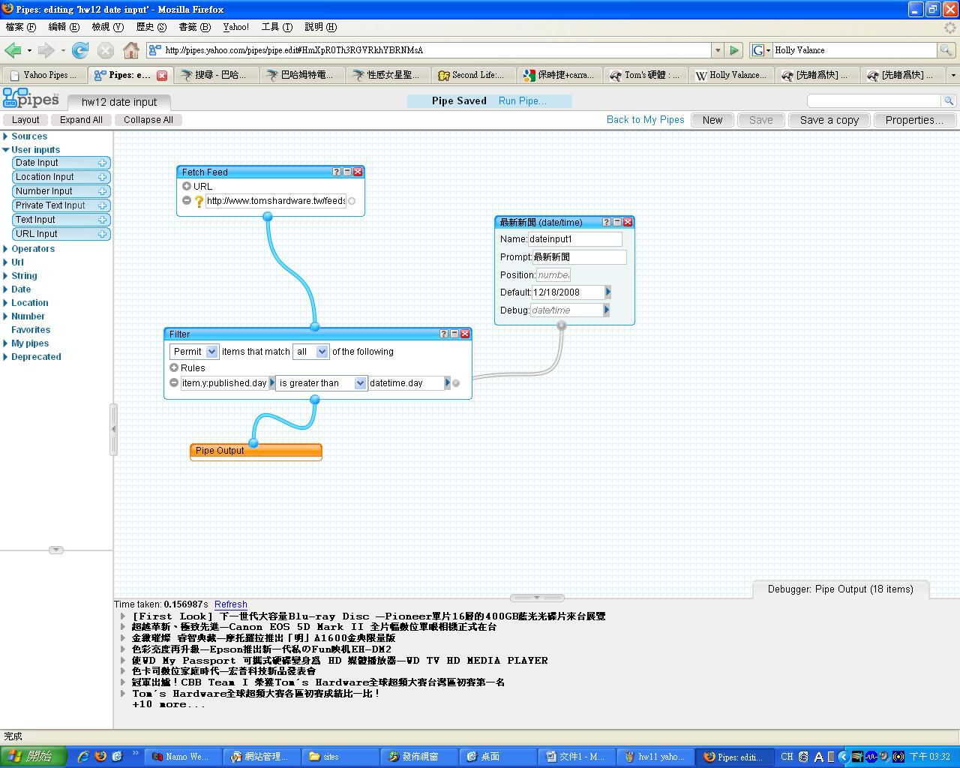
hw13 sort & tail

Pipe Web Address: http://pipes.yahoo.com/pipes/pipe.info?_id=2qH7Akfh3RGiiV9w1L3fcQ

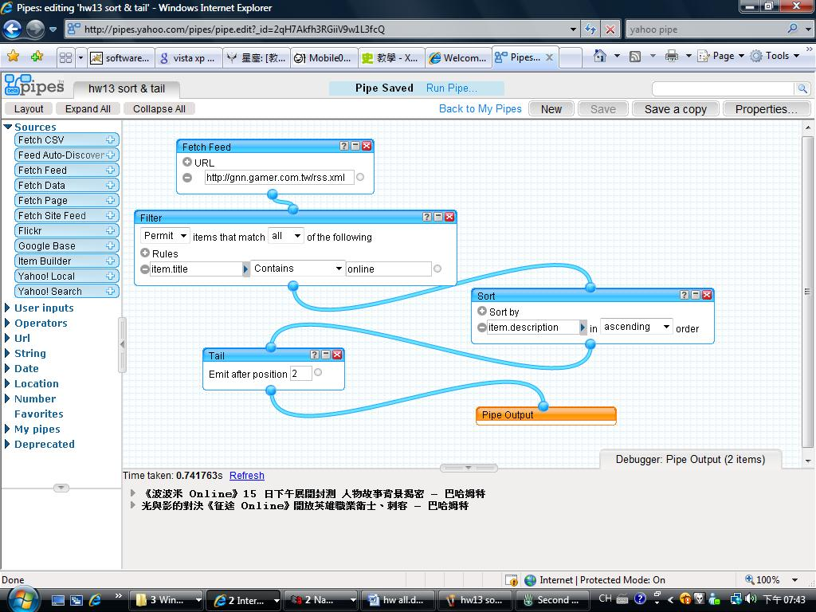

hw14 private text input

Pipe Web Address: http://pipes.yahoo.com/pipes/pipe.info?_id=2rfx347i3RGOKtev1L3fcQ

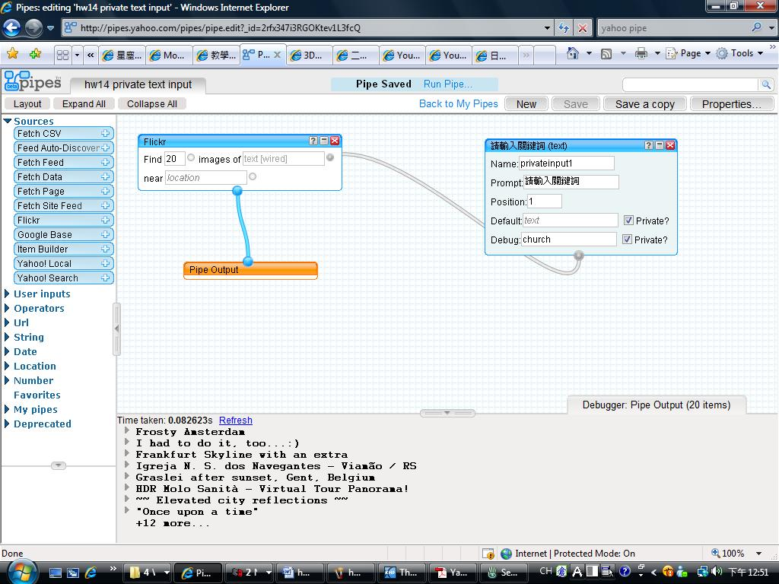

hw15 csv

Pipe Web Address: http://pipes.yahoo.com/pipes/pipe.info?_id=Ivs0fMTi3RGUB_GTbbsjiw

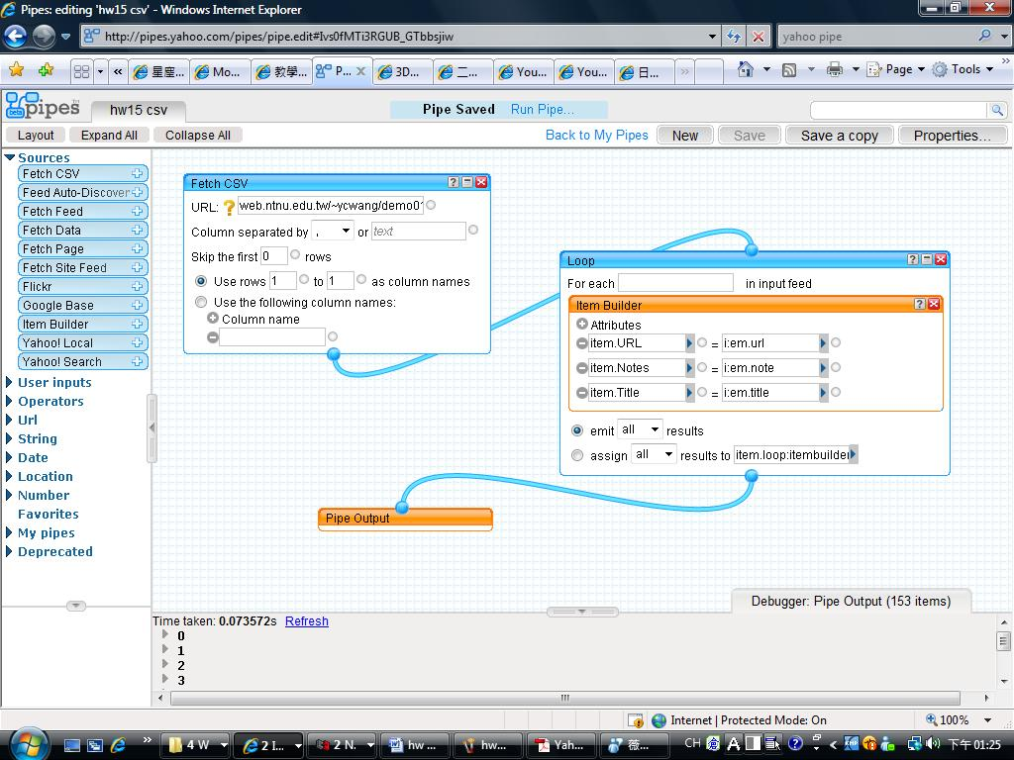

hw 16 count

Pipe Web Address: http://pipes.yahoo.com/pipes/pipe.info?_id=PJkJXSHI3RGhvQsDbrsjiw

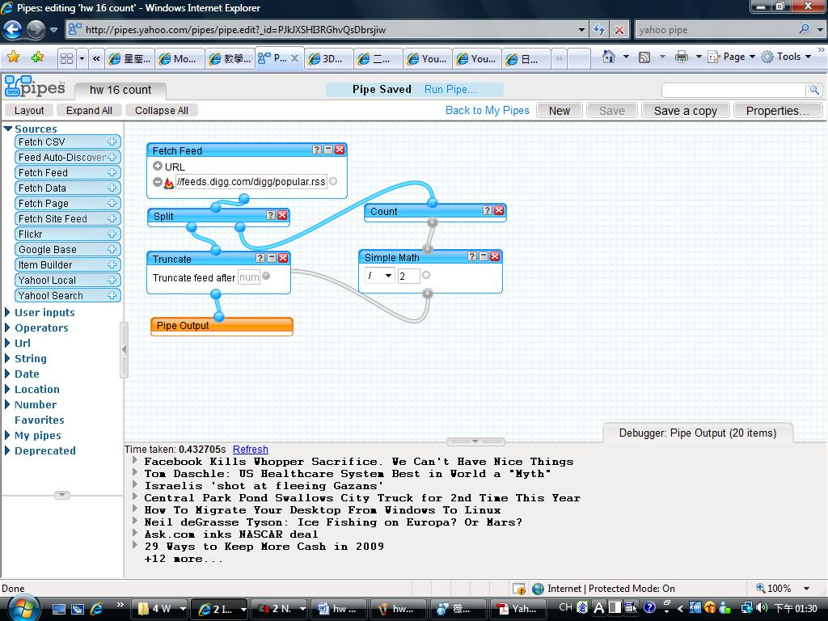

hw 17 Location Extractor

Pipe Web Address: http://pipes.yahoo.com/pipes/pipe.info?_id=3IyB8SHI3RGwdrMFbrsjiw

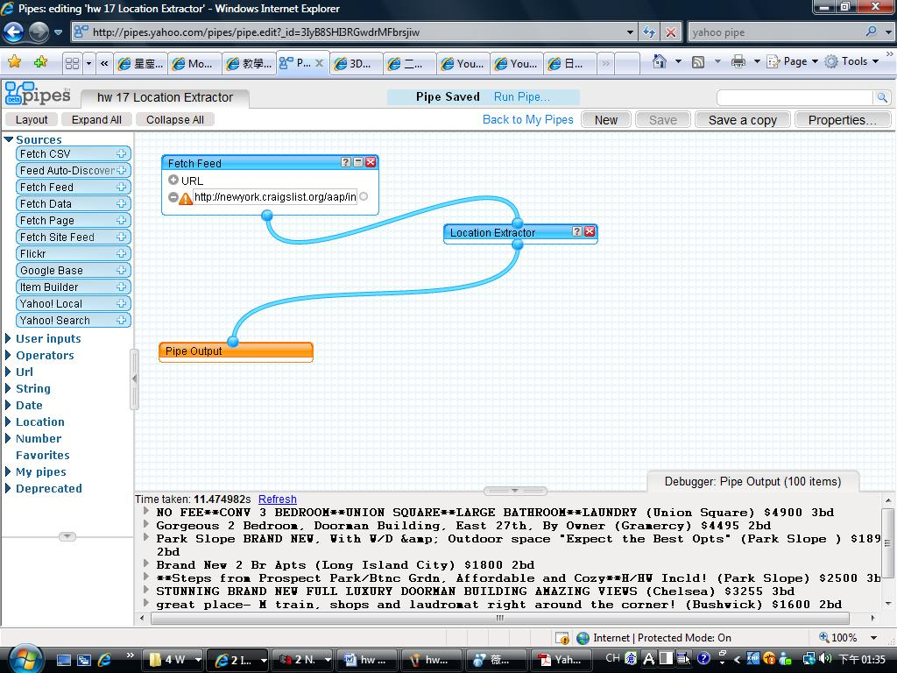

hw18 rename

Pipe Web Address: http://pipes.yahoo.com/pipes/pipe.info?_id=Fs3m2cbi3RGWqFCl1JzWFw

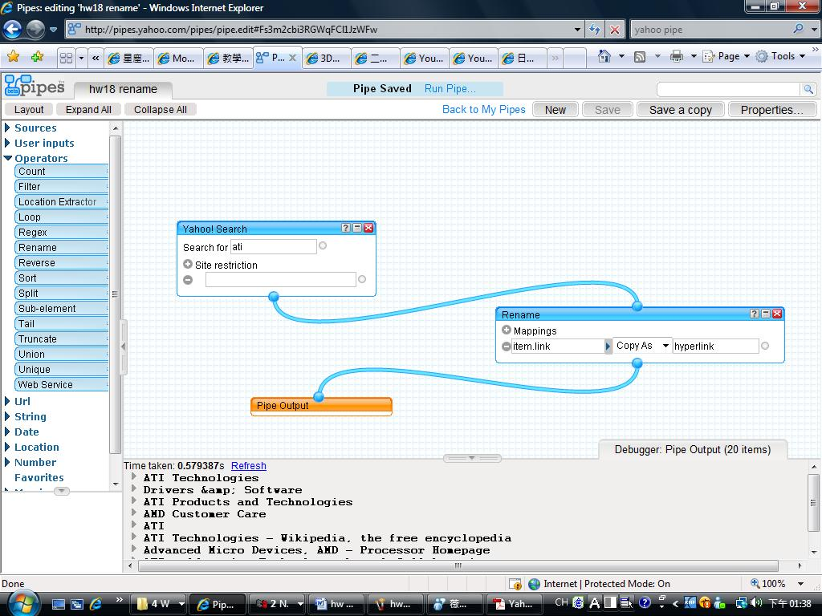

hw19 reverse & truncate

Pipe Web Address: http://pipes.yahoo.com/pipes/pipe.info?_id=dsJ8YCTI3RGwU3811L3fcQ

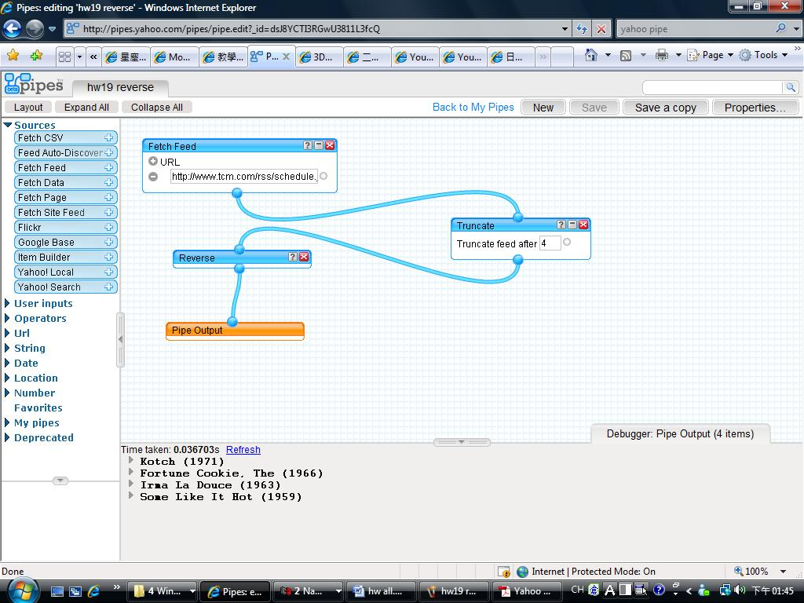

hw20 regex

Pipe Web Address: http://pipes.yahoo.com/pipes/pipe.info?_id=CpJMA8ri3RGzZR3_BRNMsA

